**INSTALLATION AND NAVIGATION OF VISUAL STUDIO-CODE**

**Installation of VS Code:**

**Steps to Download and Install Visual Studio Code on Windows 11:**

1. **Conditions:**
   * Ensure your Windows 11 is up-to-date.
   * Enough internal storage to install the software.
2. **Download:**
   * Open your web browser and go to the official visual studio website
   * Click on the "Download" button for Windows.
3. **Installation:**
   * Once the download is complete, open the installer (VSCodeSetup.exe).
   * Accept the license agreement.
   * Select the destination folder where you want to install VS Code.
   * Choose additional tasks
   * Click "Install" and wait for the installation to complete.
   * Once installed, launch VS Code.

**First-time Setup:**

**Initial Configurations and Settings:**

1. **Theme and Appearance:**
   * Go to file > Preferences > Color Theme to select your preferred theme.
2. **Font Size:**
   * Go to File > Preferences > Settings and search for "Font Size". Adjust it to your preffered.
3. **Extensions:**
   * Install essential extensions:
     + Prettier - Code formatter
     + ESLint - Linting tool
     + Live Server - Local development server
     + Python - For Python support
     + GitLens - Git supercharged
4. **Settings Sync:**
   * Enable settings sync to save your preferences across devices via File > Preferences > Settings Sync.

**User Interface Overview:**

**Main Components of the VS Code User Interface:**

1. **Activity Bar:**
   * Located on the left side, it allows you to switch between different views like Explorer, Search, Source Control, Run and Debug, Extensions, etc.
2. **Side Bar:**
   * It shows the contents of the selected view from the Activity Bar, such as file explorer, search results, or source control.
3. **Editor Group:**
   * The central area where you open and edit files. You can split this area into multiple editors side by side.
4. **Status Bar:**
   * Located at the bottom, it shows information about the opened project, such as current branch in Git, errors and warnings, language mode, line and column number, etc.

**Command Palette:**

**What is the Command Palette and How to Access It:**

-The Command Palette is a tool that allows you to access various functions and commands quickly.

* It can be accessed by pressing Ctrl+Shift+P

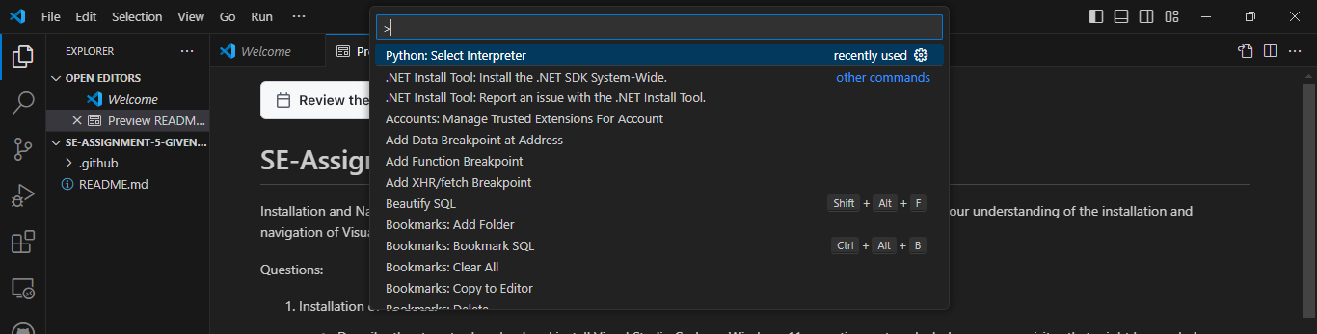

* Examples of common tasks:
  + > Open File
  + > Git: Clone
  + > Preferences: Open Settings
  + > Terminal: Create New Integrated Terminal

**Extensions in VS Code:**

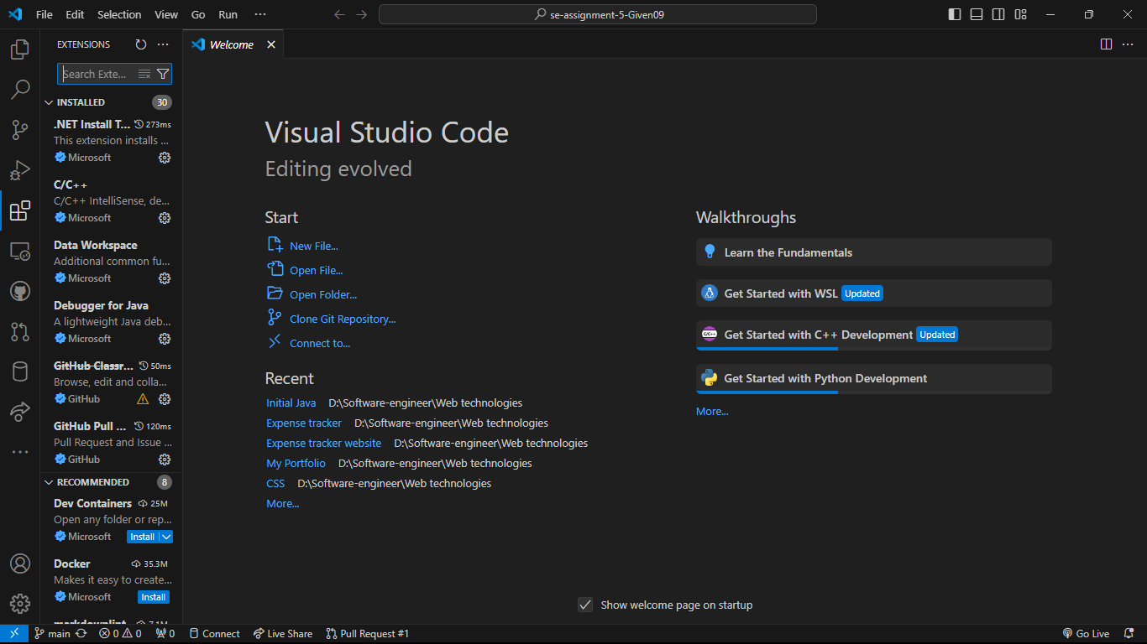

**Role of Extensions and How to Manage Them:**

* Extensions enhance the functionality of VS Code by adding new features.
* To find and install extensions:
  + Click on the Extensions view icon in the Activity Bar or press Ctrl+Shift+X.
  + Search for the desired extension and click Install.
* To manage extensions:
  + Go to View > Extensions to enable, disable, or uninstall extensions.
* Essential extensions for web development:
  + HTML CSS Support
  + JavaScript (ES6) Code Snippets
  + Bracket Pair Colorizer

**Integrated Terminal:**

**How to Open and Use the Integrated Terminal:**

* Open the integrated terminal by going to View > Terminal or pressing Ctrl+`.
* Advantages:
  + Keeps your workflow within VS Code.
  + Allows for running scripts, Git commands, and other CLI tools without switching context.
  + Supports multiple terminals.

**File and Folder Management:**

**Creating, Opening, and Managing Files and Folders:**

* **Create:**
  + Right-click in the Explorer view and select New File or New Folder.
* Open:
  + Drag and drop files or folders into the Explorer view, or go to File > Open File or Open Folder.
* **Navigation:**
  + Use the Explorer view to navigate files.
  + Use Ctrl+P to quickly open files by typing their name.
  + Use breadcrumbs at the top of the editor to navigate the file structure.

Settings and Preferences:

Customizing Settings in VS Code:

* Find settings in File > Preferences > Settings or by pressing Ctrl+,.
* Change theme:
  + Go to File > Preferences > Color Theme and select a theme.
* Adjust font size:
  + Search for "Font Size" in the settings and change the value.
  + Customize keybindings:
  + Go to File > Preferences > Keyboard Shortcuts or press Ctrl+K Ctrl+S.

**Debugging in VS Code:**

**Setting Up and Starting Debugging:**

* + Setup:
  + Open the file to debug.
  + Set breakpoints by clicking in the gutter next to the line numbers.
  + Launch Configuration:
  + Go to Run > Add Configuration.
  + Select the appropriate environment (e.g., Node.js, Python).
  + Start Debugging:
  + Press F5 to start debugging.
  + Use the Debug toolbar to control the execution (continue, step over, step into, step out).

**Using Source Control:**

**Integrating Git with VS Code:**

1. Initialize Repository:
   * Open your project folder.
   * Go to the Source Control view or press Ctrl+Shift+G.
   * Click Initialize Repository.
2. Making Commits:
   * Stage changes by clicking the + icon next to changed files.
   * Enter a commit message and click the checkmark icon to commit.
3. Pushing to GitHub:
   * Click the ... menu in the Source Control view.
   * Select Push to push changes to your remote repository.